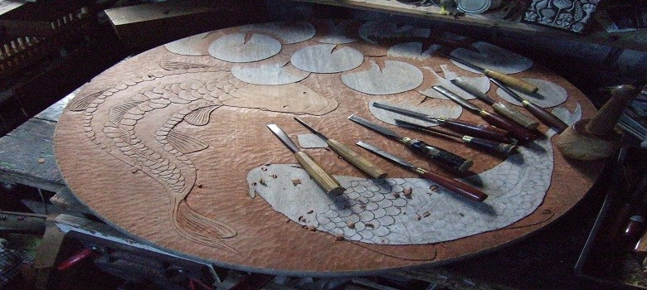
A five week introductory course in Woodcarving at Nigel’s Workshop in Challock surrounded by woodland
small groups 5 persons max
A taster course for those who are new to Woodcarving featuring:
- Toolcare and sharpening
- Wood knowledge
- Design and composition advice
- Letter carving
- Relief carving
Wood can be supplied at a small cost, but feel free to bring your own. Experienced woodcarvers are also welcome.
Tools available but please feel free to bring your own.
Tea, coffee, cake and jovial atmosphere provided.
Cost per 5 week course £125 payable in advance.
Mid-week classes begin Wednesday 1st November 2017 on concurrent Wednesdays 12-3pm.
Weekend classes begin Saturday 4th November 2017 on concurrent Saturdays 12-3pm.
Venue- Laburnum, Buck Street, Challock, Kent. TN25 4AR (opposite Victoriana Nurseries) on the A251 halfway between Ashford and Faversham. - onsite parking available
